CS4375 Fall 2025 Homework Report
<Christian Lopez> Submitted on <11/10/25>
<celopez8@miners.utep.edu>

HW 4: Lazy Allocation for xv6

Task 1. freepmem() system call
For this task, I learned about creating and connecting a new system call in xv6 by changing multiple kernel files. Testing freepmem() with the two provided file, free and memory-user showed me how physical memory is tracked throughout the system and how it’s freed. It also helped me visualize the difference between user programs and kernel memory management.
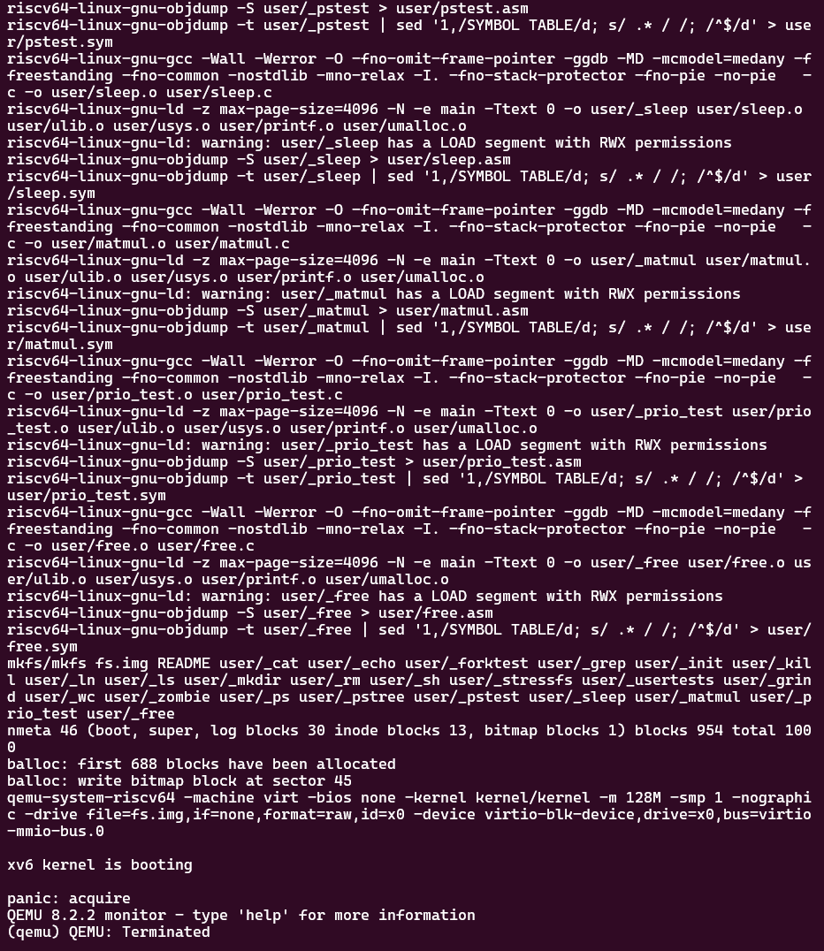

Task 2. Change sbrk() so that it does not allocate physical memory.
In changing sbrk() so that it doesn’t allocate physical memory, one error I came upon was “panic:acquire” when trying to run qemu. I believe this happened because the program expected page mappings that no longer existed. I learned about removing physical allocation effects and how missing mappings can lead to kernel panics that have to be accounted for.

Task 3. Handle the load and store faults that result from Task 2
After first dealing with the load and store faults some errors still showed up whenever accessing unmapped memory. From this, I learned how page faults happen and why they’re triggered, for example handling them by allocating physical pages on demand. The testing with memory-user actually helped me fix the logic and confirm that the lazy allocation was actually working.

Task 4. Fix kernel panic and any other errors.
After fixing the other errors, I was able to run qemu with no issue. From this, I learned how to ensure functions like uvumap() and uvmcopy() deal with lazy allocation. The biggest problem I encountered when trying to deal with these issues was tracking down which parts of the code I initially wrote was causing the panic, as I reread the homework and slides, I later realized which functions I needed to change and why.

Task 5. Test your lazy memory allocation.
For the first case, the purpose of the test is to check that lazy memory allocation works as intended and free the memory without touching it. This test confirms that the physical pages are not actually allocated until they’re accessed.
For the second case, the test touches every page of the allocated memory to make sure that the physical pages are allocated only when they’re accessed, checking that lazy allocation maps pages on demand in valid way and the memory usage increases.
For the third case, the test only touches 1 out 16 pages to show partial allocation, it shows that only the accessed pages actually take up physical memory.

Extra Credit Task 6. Enable use of the entire virtual address space.
List what files you changed and describe the changes.
Summarize what you learned by carrying out this task.

Extra Credit Task 7. Allow a process to turn memory overcommitment on and off.
Describe your approach to this task. Commit and push your code changes to your hw4 branch. Show the results of a test program that turns memory overcommitment on and off.
Summarize what you learned by carrying out this task.

